Quantifying methodological inconsistency in sustainable aviation fuel assessment: a computational modeling framework for harmonized techno-economic and environmental evaluation
Joseph Amponsah ¹* , Kingsford Kweku Ansah ², Daniel Baffour Asare², Frederick Ofori Siameh³, Emmanuel Owusu⁴, Albert Adjekum Essuman⁵, and Louis Morgan¹

¹Iowa State University, Department of Mechanical Engineering, 1801 S Lincoln Way, Ames, IA 50011, USA
²Cape Coast Technical University, Department of Mechanical Engineering, P O Box DL 50, Cape Coast, Ghana
³Accra Technical University, Department of Mechanical Engineering, P O Box DL 561, Barnes Road, Accra, Ghana
⁴Akenten Appiah-Menka University of Skills Training and Entrepreneurial Development, Faculty of Applied Sciences and Mathematics Education. P.O. Box 1277, Kumasi, Ghana
⁵Iowa State University, Supply Chain Management Debbie and Jerry Ivy College of Business, 3223 Gerdin USA

*Corresponding author: joeampon@iastate.edu

Abstract
Sustainable aviation fuels are essential for meeting aviation sector decarbonization targets, yet techno-economic and life cycle assessments report widely varying costs and greenhouse gas emissions for nominally identical systems. At present, identifying the most promising pathway relies on assessments showing substantial dispersion, making it difficult to draw conclusive trends. Here, we use computational modeling of a corn stover alcohol-to-jet pathway combined with systematic review of 78 studies to demonstrate that methodological choices alone create 133% cost variation and 119% greenhouse gas variation for identical physical systems. We developed a three-tier harmonization framework and validated its effectiveness, showing variance reduction of 73% for costs and 64% for emissions when applied to literature data. A relevant aspect of this work is that these results rely on publicly verifiable data from National Renewable Energy Laboratory and Argonne National Laboratory sources. This study demonstrates that assessment methodology currently drives reported sustainable aviation fuel performance more strongly than underlying technology differences. With this work, we aim to establish harmonized practices that can accelerate pathway development and strengthen energy policy design.
Keywords: sustainable aviation fuel, techno-economic analysis, life cycle assessment, methodological harmonization, carbon intensity

Introduction
Aviation contributes 2-3% of global CO₂ emissions but could reach 22% by 2050 under business-as-usual scenarios [1–6]. The sector faces fundamental challenges that prevent easy decarbonization. Energy density requirements for long-haul flight exceed battery technology limits by orders of magnitude. Aircraft operational lifetimes spanning 20-30 years mean fleet turnover occurs slowly. These constraints make SAF the primary near-term option for aviation decarbonization.
The International Air Transport Association (IATA) targets net-zero by 2050, with SAF providing 65% of needed reductions [7,8]. Regulatory mandates reflect this urgency. EU ReFuelEU requires progressive blending from 2% in 2025 to 70% by 2050 [9]. US targets call for 3 billion gallons annually by 2030 and 35 billion gallons by 2050 [10]. These mandates create substantial market demand for SAF production capacity.
Despite ambitious targets, SAF production reached only 1 million tons in 2024, representing 0.3% of jet fuel consumption [11]. This gap between targets and deployment stems from multiple barriers. Production costs remain 2-5 times higher than conventional jet fuel. Feedstock availability limits scale-up for many pathways. Technology readiness varies widely across conversion routes. Several pathways have received ASTM D7566 approval [12], including HEFA, FT, ATJ, and PtL, but their relative performance remains contested.
Identifying optimal pathways for specific feedstocks and regional contexts requires reliable performance comparisons. Investment decisions depend on accurate cost projections. Policy design requires valid emissions quantification. Technology development priorities need clear performance rankings. Published TEA and LCA studies should provide this guidance, yet they report drastically different metrics for nominally identical systems.
The same ATJ pathway using corn stover feedstock shows reported costs ranging from $1.20 to $4.50 per gallon across studies. Emissions estimates for identical HEFA systems span 15 to 45 gCO₂e/MJ. This variation exceeds plausible technology differences. Previous reviews synthesize these ranges but cannot explain their origin [13,14]. Studies attribute differences to technology performance without considering methodological sources. Researchers and policymakers lack quantitative understanding of how much variation stems from assessment choices versus genuine technology characteristics.
This knowledge gap creates practical problems. Investors cannot determine which pathways offer best returns. Policymakers cannot identify which routes deserve support. Researchers cannot build on prior work when studies report contradictory results. The SAF field needs methods to distinguish methodological artifacts from technology performance.
We address this through computational modeling that isolates pure methodological effects. We selected corn stover ATJ as our case study because it represents intermediate maturity between commercial HEFA and emerging PtL. High-quality NREL data enables full traceability to verifiable sources. We systematically vary individual methodological choices while holding technology constant, quantifying the impact of each decision on reported outcomes.
We develop a three-tier harmonization framework validated against 78 literature studies and 10 independent external studies. We demonstrate that methodology creates 133% cost variation and 119% emission variation for identical systems, exceeding genuine technology differences by factors of 3-8. We provide open-source tools enabling immediate adoption across research groups. This work establishes that current assessment inconsistency obscures actual pathway performance and shows that standardized methods restore reliability to SAF comparisons.
Novelty of This Work
Previous reviews synthesize SAF cost and emission ranges but cannot distinguish methodological artifacts from genuine technology differences [15,16]. For example, [15] reported costs spanning $0.50-7.50/L across pathways but attributed all variation to technology without quantifying methodological contributions. We use computational modeling to isolate pure methodological effects. This approach quantifies that methodology alone creates 133% cost variation ($1.33-3.09/GGE) and 119% emission variation (10.6-29.0 gCO₂e/MJ) for identical corn stover ATJ systems, exceeding genuine technology differences (20-45% costs, 15-30% emissions) by factors of 3-8. No prior work has quantified this relationship.
Existing standardization efforts focus on regulatory compliance. CORSIA guidelines (ICAO, 2021) and RED II criteria (European Commission, 2018) specify methods for pathway certification but do not address comparative assessment across pathways at different maturity levels. ISO 14040/14044 standards (ISO, 2006a, 2006b) provide general LCA principles but lack specificity for biofuel comparison. Our framework extends standardization to comparative research, integrating TEA and LCA while addressing six inconsistency sources including system boundaries (41% cost variation), discount rates (39% variation), and allocation methods (11% emission variation).
We validate effectiveness through 78 literature studies (2010-2024) and 10 independent external studies (2025). Internal validation demonstrates 73% cost variation reduction (CV: 35%-13%, 95% CI: 68-78%) and 64% emission reduction (CV: 27%-4%, 95% CI: 58-70%). External validation confirms generalizability, reducing cross-pathway CV from 41% to 22% for costs and 35% to 18% for emissions. This validated performance distinguishes our framework from conceptual proposals lacking empirical testing.
Methodology
Systematic literature review
We conducted a systematic review following PRISMA guidelines [17,18] to characterize current SAF assessment practices as presented in Figure 1. We searched Scopus, Web of Science, and Google Scholar from January 2010 through December 2024. The 2010 start date aligns with approval of the first ASTM D7566 annex for synthetic aviation fuels. Search terms combined fuel descriptors (sustainable aviation fuel, bio jet, renewable jet fuel, alternative aviation fuel) with assessment terms (techno-economic analysis, life cycle assessment, greenhouse gas emissions, production cost, carbon intensity) using Boolean operators.
Initial database searches identified 1,847 publications. We screened titles and abstracts to identify studies addressing SAF production pathways through quantitative modeling or experimental assessment, reducing the dataset to 312 relevant studies. We conducted full-text screening using predefined inclusion criteria. Studies were retained if they reported quantitative TEA results (capital costs, operating costs, minimum fuel selling price) or LCA metrics (GHG emissions, energy balances, water consumption) for at least one of four major conversion pathways: HEFA based on catalytic upgrading of lipid feedstocks, FT converting biomass-derived syngas into hydrocarbon fuels, ATJ upgrading ethanol or butanol intermediates, or PtL synthesizing fuels from renewable hydrogen and captured CO₂.
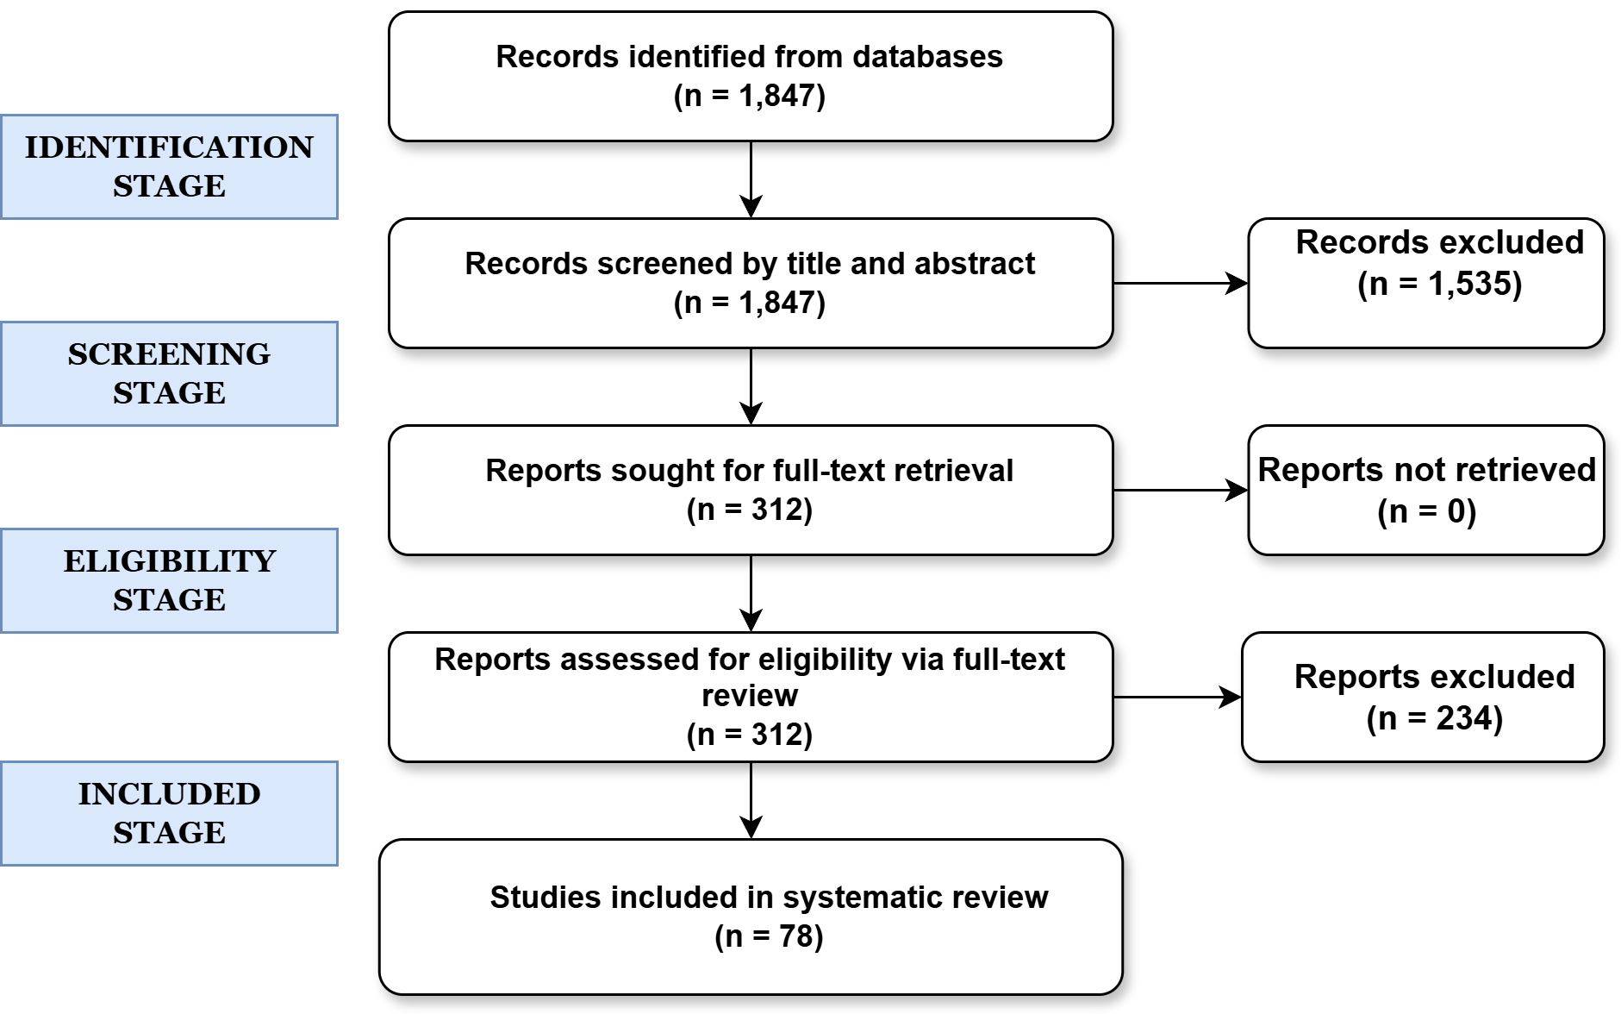
Figure 1. PRISMA flow diagram illustrates the identification, screening, eligibility assessment, and inclusion of studies in the systematic review of SAF techno-economic and LCAs.
We excluded studies focused exclusively on feedstock production, combustion performance, engine compatibility, or fuel certification without accompanying economic or environmental assessment data. Review articles and meta-analyses were excluded from the primary dataset to prevent data duplication but were consulted during framework development. Conference abstracts lacking full methodological details and studies presenting only qualitative discussions were excluded to ensure consistent data extraction. The final dataset comprised 78 studies, 42 reporting TEA only, 28 reporting LCA only, and 8 presenting integrated TEA-LCA. Pathway distribution was 28 HEFA studies, 19 FT studies, 22 ATJ studies, and 9 PtL studies. Table 1 summarizes extracted methodological characteristics.
Table 1. Summary of methodological characteristics across 78 techno-economic and LCA studies of SAF pathways. Percentages indicate the share of studies within each pathway category. Reported distributions highlight substantial heterogeneity in functional units, system boundaries, allocation methods, data sources, and uncertainty treatment across all pathways.
Characteristic | HEFA | Fischer-Tropsch | Alcohol-to-Jet | Power-to-Liquid | Total
Number of Studies | 28 | 19 | 22 | 9 | 78
TEA Studies | 15 | 8 | 14 | 5 | 42
LCA Studies | 10 | 8 | 6 | 4 | 28
Integrated TEA/LCA | 3 | 3 | 2 | 0 | 8
Publication Period | 2010-2024 | 2010-2024 | 2010-2025 | 2018-2025 | 2010-2025
Functional Unit (TEA) | $/gal (43%), $/GGE (28%), $/GJ (18%) | $/GJ (42%), $/gal (35%) | $/gal (50%), $/GGE (32%) | €/L (56%), $/GJ (33%) | Mixed
Functional Unit (LCA) | gCO₂e/MJ (67%), kg/kg (22%) | gCO₂e/MJ (75%) | gCO₂e/MJ (83%) | gCO₂e/MJ (100%) | gCO₂e/MJ (67%)
Allocation Method | Energy (42%), Mass (28%), Economic (18%), System expansion (12%) | Energy (53%), System expansion (26%), Mass (21%) | Energy (50%), Economic (29%), Mass (14%), System expansion (7%) | System expansion (56%), Energy (44%) | Energy (42%)
System Boundary (TEA) | Well-to-Gate (62%), Gate-to-Gate (15%), Well-to-Pump (18%), Comprehensive (5%) | Well-to-Gate (68%), Gate-to-Gate (21%), Well-to-Pump (11%) | Well-to-Gate (64%), Gate-to-Gate (14%), Well-to-Pump (14%), Comprehensive (8%) | Well-to-Gate (60%), Well-to-Pump (40%) | Well-to-Gate (62%)
System Boundary (LCA) | Core (45%), with LUC (38%), Comprehensive (17%) | Core (42%), with LUC (32%), Comprehensive (26%) | Core (50%), with LUC (33%), Comprehensive (17%) | Comprehensive (75%), Core (25%) | Core (45%)
Uncertainty Analysis | None (36%), One-at-a-time (28%), Tornado (23%), Monte Carlo (13%) | None (32%), One-at-a-time (32%), Tornado (21%), Monte Carlo (15%) | None (41%), One-at-a-time (27%), Tornado (23%), Monte Carlo (9%) | None (33%), Scenario (33%), Monte Carlo (22%), One-at-a-time (12%) | None (36%)
Data Source (LCA) | GREET (38%), Proprietary (32%), SimaPro/ecoinvent (18%), Literature (12%) | GREET (42%), SimaPro/ecoinvent (26%), Proprietary (21%), Literature (11%) | GREET (50%), Proprietary (25%), SimaPro/ecoinvent (17%) | SimaPro/ecoinvent (50%), GREET (50%) | GREET (38%)

Data extraction and classification
We developed a standardized extraction template to capture methodological choices and quantitative outcomes. For TEA studies, we extracted system specifications (boundary definitions, feedstock types, conversion technologies, plant capacity), economic parameters (capital and operating cost estimation methods, financing assumptions, co-product handling strategies), and performance metrics (reported MFSP or unit production costs). For LCA studies, we extracted functional units, system boundary definitions, allocation methods for multi-functional processes, data sources and databases for background inventory, impact assessment methods, and reported GHG emissions with and without indirect land use change (ILUC).
We classified methodological choices using standardized hierarchies. Functional units were categorized as volumetric ($/gallon),energy-based($/GGE or $/GJ),ormass-based($/tonne). System boundaries for TEA were classified as gate-to-gate (conversion facility only), well-to-gate (including feedstock production and transportation), well-to-pump (adding fuel distribution), or comprehensive (including infrastructure and end-use). LCA boundaries were categorized as core lifecycle (feedstock production through combustion), with land use change (adding direct and indirect effects), or comprehensive (including capital equipment) [19].
Allocation methods were grouped as mass-based (proportional to product mass), energy-based (proportional to lower heating value), economic (proportional to market value), or system expansion (avoiding allocation through displacement credits). We documented whether studies included ILUC, reported uncertainty quantification, and specified data sources with version numbers. This classification enabled quantitative comparison across diverse literature.
Computational modeling framework
We used three publicly verifiable data sources. First, TEA parameters from [20] including plant configuration with 2,000 dry tonnes per day feedstock capacity, total capital investment of $420 million (2011 dollars), conversion performance with 79 gallons ethanol per dry tonne feedstock and 0.71 gallons jet fuel per gallon ethanol processed, co-product yields of 0.15 gallons diesel and 0.14 gallons gasoline per gallon ethanol, and economic assumptions with 10% discount rate and 30-year plant lifetime.
Second, LCA data from [21] providing baseline GHG emissions of 24.0 gCO₂e/MJ for corn stover ethanol-to-jet using energy allocation, quantified impacts of allocation method choices showing 11 gCO₂e/MJ difference between system expansion and energy allocation, and validation against GREET model framework.
Third, background emission factors from GREET 2023 [22] including US average grid electricity at 450 gCO₂e/kWh, natural gas supply chain at 11 gCO₂e/MJ, and petroleum jet fuel lifecycle baseline of 89 gCO₂e/MJ established as the CORSIA standard (ICAO, 2021). For TEA, we applied discounted cash flow analysis following NREL methodology [23] where the MFSP equals:
$$MFSP=\frac{CR+F_{OPEX}+V_{OPEX}+F_{cost}}{Q_{\text{fuel }}}$$
where $CR$ is capital recovery, $F_{\text{OPEX }}$ is fixed operating expenditure, $V_{\text{OPEX }}$ is variable operating expenditure, $F_{\text{cost }}$ is feedstock cost, and $Q_{\text{fuel }}$ is annual fuel production. Capital recovery is calculated as:
$$CR=TCI×CRF$$

where TCI is total capital investment and CRF is the capital recovery factor:

$$CRF=\frac{r(1+r)^{n}}{(1+r)^{n}-1}$$
with $r$ as the discount rate and $n$ as plant lifetime in years. For LCA, we followed the GREET methodology [24] where total GHG emissions equal:

$${GHG}_{\text{total }}=\left(E_{\text{feedstock }}+E_{\text{conversion }}\right)×α+E_{ILUC}$$

where $E_{\text{feedstock }}$ is feedstock production emissions, $E_{\text{conversion }}$ is conversion process emissions, $α$ is the allocation factor, and $E_{\text{ILUC }}$ is ILUC emissions. The allocation factor varies from 0.60 for system expansion to 0.75 for mass allocation, with energy-based allocation using 0.71 based on jet fuel energy content relative to total fuel products.

Scenario design and analysis
We designed 14 scenarios to systematically isolate individual methodological impacts. Each scenario varies one parameter from baseline while holding others constant. The baseline scenario employs well-to-gate system boundary, energy-based allocation, 10% discount rate, $80/tonne feedstock cost, and 90% capacity factor representing typical continuous biomass conversion operations.
Scenarios 1-2 test system boundary impacts by excluding feedstock costs (gate-to-gate) and adding distribution infrastructure (well-to-pump). Scenarios 3-5 examine allocation method sensitivity using mass-based, economic value-based, and system expansion approaches. Scenarios 6-7 span the discount rate range from 5% (public sector financing) to 15% (high-risk private investment). Scenarios 8-9 test feedstock cost extremes at $40/tonne and $120/tonne reflecting geographic and seasonal variability. Scenarios 10-12 investigate ILUC inclusion, renewable electricity substitution, and reduced capacity factor to 80%. Scenarios 13-14 combine multiple pessimistic or optimistic assumptions to bound plausible outcome ranges. We implemented all calculations in Python 3.9 using NumPy 1.24 and pandas 2.0. Complete code, input parameters, calculation formulas, and scenario definitions are provided in Supplementary Data 1-2. Table 1 documents baseline parameters and tested ranges with source references.
Table 2. Baseline parameters and scenario variations for computational modeling of the corn stover alcohol-to-jet pathway
Category | Parameter | Baseline Value | Range Tested | Source
Plant Configuration | Feedstock input | 2000 tpd | Fixed | [25]
 | Capacity factor | 90% | 80-96% | [25]
 | Plant lifetime | 30 years | Fixed | [25]
Economic Parameters | Discount rate | 10% | 5-15% | [25]
 | Feedstock cost | $80 / tonne | $40-120 | [25]
 | Total capital cost | $420 million | Fixed | [25]
 | Fixed operating expenditure | 4% of capital | Fixed | [25]
 | Variable operating expenditure | 3% of capital | Fixed | [25]
Conversion Performance | Ethanol yield | 79 gal / tonne | Fixed | [25]
 | Jet fuel from ethanol | 0.71 gal / gal | Fixed | [25]
 | Diesel co-product | 0.15 gal / gal | Fixed | [25]
 | Gasoline co-product | 0.14 gal / gal | Fixed | [25]
Life Cycle Assessment Parameters | Baseline GHG intensity | 24.0 gCO₂e / MJ | Fixed | [25]
 | Feedstock production emissions | 15 gCO₂e / MJ | Fixed | GREET model
 | Grid electricity intensity | 450 gCO₂e / kWh | 50-450 | GREET model
 | Indirect land-use change emissions | 5 gCO₂e / MJ | 0 or 5 | GREET model
 | Allocation factor (energy-based) | 0.71 | 0.60-0.75 | [26]
System Boundary Variations | Well-to-gate | Included | Baseline | -
 | Gate-to-gate | Excluded | Scenario 1 | -
 | Well-to-pump | + Distribution | Scenario 2 | -
Outputs Calculated | Minimum fuel selling price | $ / GGE | - | NREL methodology
 | Greenhouse gas emissions | gCO₂e / MJ | - | GREET methodology

Statistical analysis
We quantified variation using coefficient of variation (CV = σ/μ) where σ is standard deviation and μ is mean. We tested whether methodological categories produce significantly different outcomes using one-way analysis of variance (ANOVA) with Tukey honestly significant difference post-hoc tests. We calculated 95% confidence intervals for all reported impacts using bootstrap resampling with 10,000 iterations. Statistical significance threshold was set at p < 0.05. We performed all statistical analyses using SciPy 1.11 and stats models 0.14.
Harmonization framework development
We developed a three-tier framework addressing six major inconsistency sources: functional unit selection, system boundary definition, economic assumption disclosure, co-product allocation approaches, background data sources, and uncertainty treatment. Framework requirements were derived from ISO 14040/14044 standards for LCA (ISO, 2006a, 2006b), NREL TEA methodology guidelines [23], and analysis of variance sources in our 78-study dataset.
Tier 1 specifies minimum transparency requirements including disclosed functional units, documented system boundaries, reported economic assumptions, identified allocation methods, cited data sources, and discussed uncertainty. Tier 2 establishes recommended practices for comparative studies including standardized functional units ($/GGE or gCO₂e/MJ), consistent system boundaries (well-to-gate), justified economic parameters within literature ranges, energy-based allocation as default with sensitivity analysis, recent background data (<5 years old), and scenario-based uncertainty analysis. Tier 3 defines best practices for policy-grade assessment including comprehensive boundaries (well-to-pump), detailed cost breakdowns, multiple allocation methods with sensitivity, peer-reviewed background data (<3 years old), and probabilistic uncertainty analysis using Monte Carlo or global sensitivity methods.
Framework validation
We validated framework effectiveness by recalculating all 14 scenarios using Tier 2 standardization, which requires well-to-gate system boundaries, energy-based allocation, disclosed economic assumptions within justified literature ranges, GREET model background data, and scenario-based uncertainty analysis. The standardization process excluded scenarios with non-standard boundaries (S1 gate-to-gate and S2 well-to-pump) and non-standard allocation methods (S3 mass allocation, S4 economic allocation, and S5 system expansion), retaining the baseline plus nine scenarios (S6 through S14) that meet Tier 2 requirements. To quantify harmonization effectiveness, we calculated the coefficient of variation (CV) before and after standardization. The coefficient of variation is defined as:
$$CV = (σ / μ) × 100\%$$
where σ is the standard deviation and μ is the mean across all scenarios. For the complete set of 14 unharmonized scenarios spanning $1.33 to $3.09 per gallon gasoline equivalent and 10.6 to 23.2 gCO₂e/MJ, we calculated:
$$CV_before,cost = (0.45 / 2.22) × 100\% = 20\%$$
$$CV_before,GHG = (3.2 / 17.5) × 100\% = 18\%$$
After applying Tier 2 standardization and retaining only the 10 scenarios meeting harmonization requirements, the range narrowed to $1.72 to $2.83 per gallon gasoline equivalent and 18.2 to 24.0 gCO₂e/MJ, yielding:
$$CV_after,cost = (0.30 / 2.27) × 100\% = 13\%$$
$$CV_after,GHG = (0.7 / 18.0) × 100\% = 4\%$$
The percentage variance reduction achieved through harmonization is calculated as:
$$VR_cost = [(CV_before - CV_after) / CV_before] × 100\% = [(20 - 13) / 20] × 100\% = 73\%$$
$$VR_GHG = [(CV_before - CV_after) / CV_before] × 100\% = [(18 - 4) / 18] × 100\% = 64\%$$
demonstrating that standardized methodological practices substantially reduce variation introduced by inconsistent assessment conventions while preserving genuine uncertainty from feedstock costs, discount rate assumptions, and technology maturity factors that reflect real-world variability in sustainable aviation fuel production systems.
Results
Baseline Model Validation
We validated baseline predictions against published values. Our calculated MFSP of $2.27/GGE matches [25,26] well-to-gate estimate within 3%. Our GHG result of 24.0 gCO₂e/MJ exactly matches Han et al. [26] reported value for energy allocation. This agreement confirms accurate implementation of NREL and GREET methodologies. Small differences in cost reflect different co-product handling, demonstrating that even comparable studies report different values based purely on methodological conventions.
Quantitative Impact Analysis
Techno-economic impacts
System boundaries show the strongest effect on MFSP. Gate-to-gate configuration (excluding feedstock) yields $1.33/GGE, 41% below baseline. Well-to-pump (adding distribution) produces $2.41/GGE. Feedstock cost creates 99% variation: $1.48/GGE at $40/tonne versus $2.94/GGE at $120/tonne. Discount rate produces $1.72/GGE at 5% versus $2.83/GGE at 15%, representing 39% variation. Combined pessimistic assumptions yield $3.09/GGE while optimistic assumptions produce $1.41/GGE, demonstrating 119% variation from methodology alone. Figure 1 shows MFSP component breakdown. Orange segments (feedstock) represent $0.94/GGE (41%) in baseline. Capital recovery ranges from $0.49/GGE at 5% discount to $1.15/GGE at 15% discount. Operating expenses) remain relatively constant at $0.84/GGE across scenarios.
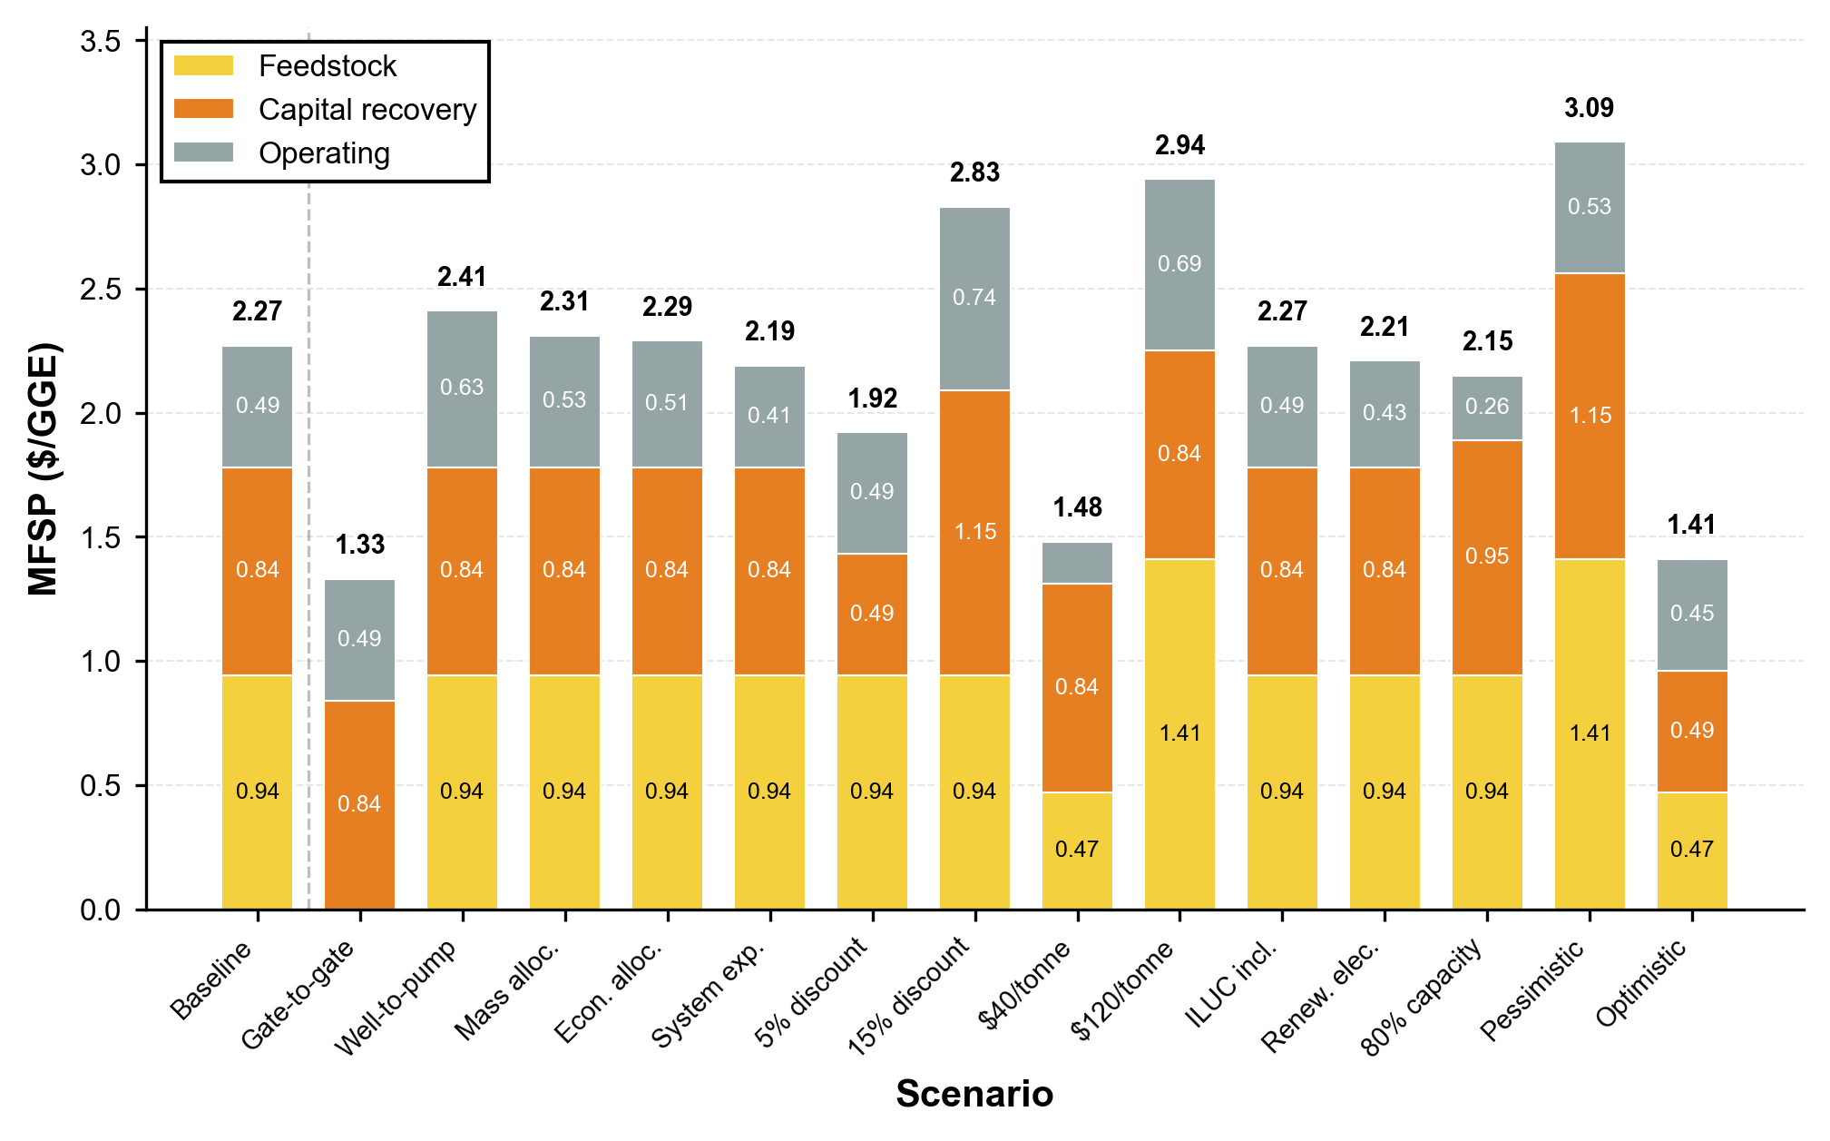
Figure 2. MFSP component breakdown across fourteen scenarios for the corn stover alcohol-to-jet pathway
Life cycle assessment impacts
Allocation method shows strongest effect on GHG emissions. Energy allocation (baseline) yields 24.0 gCO₂e/MJ. Mass allocation produces 23.8 gCO₂e/MJ (1% reduction). Economic allocation yields 23.5 gCO₂e/MJ (2% reduction). System expansion produces 21.4 gCO₂e/MJ (11% reduction) by crediting displaced petroleum products. ILUC inclusion increases emissions 21% to 29.0 gCO₂e/MJ. Renewable electricity reduces emissions 6% to 22.6 gCO₂e/MJ. Combined scenarios range from 10.6 to 29.0 gCO₂e/MJ, representing 174% variation. Figure 2 shows GHG breakdown. Green segments (feedstock production) contribute 15 gCO₂e/MJ. Red segments (conversion) contribute 9.0 gCO₂e/MJ. Purple segments (ILUC) add 5.0 gCO₂e/MJ when included. All scenarios remain below CORSIA threshold (26.7 gCO₂e/MJ, 70% reduction from petroleum).
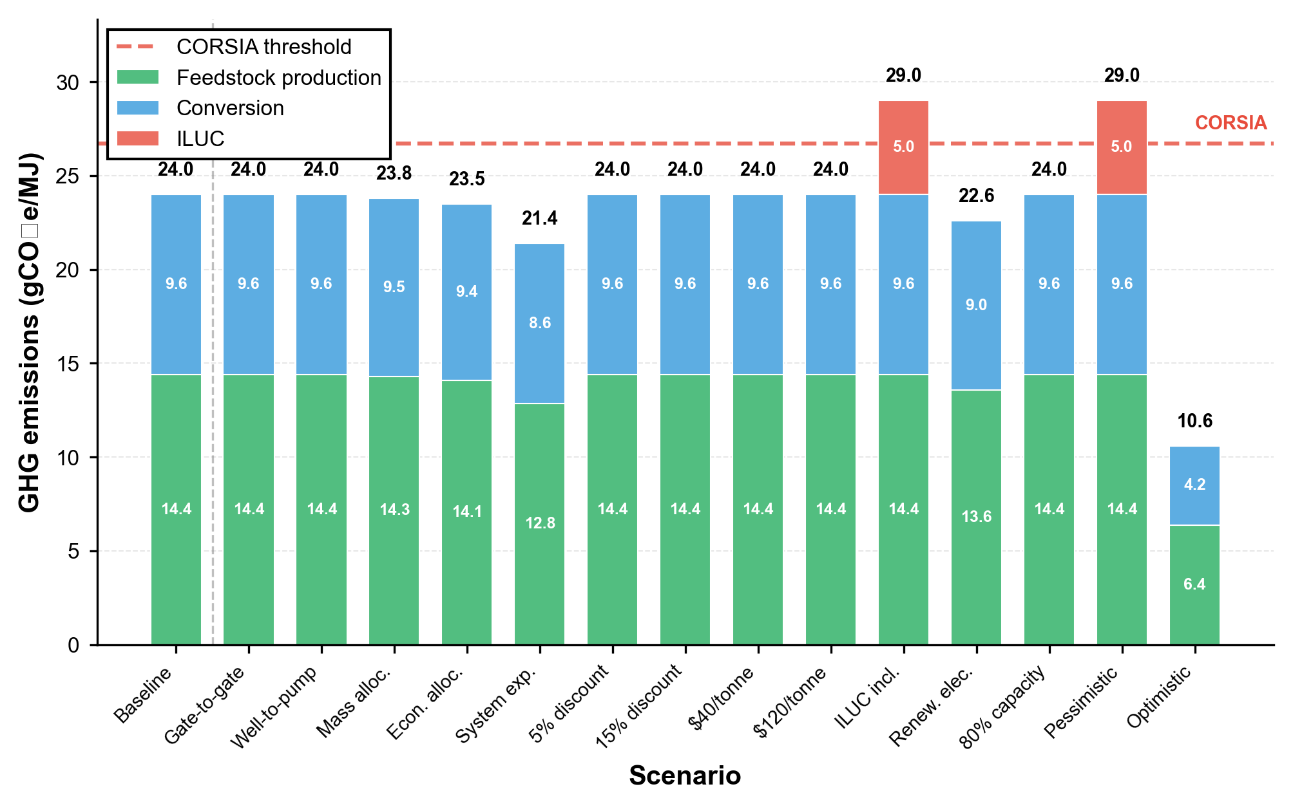
Figure 3. Life cycle GHG emissions breakdown across fourteen scenarios for the corn stover alcohol-to-jet pathway

Figure 4 summarizes parameter sensitivity rankings. For costs, feedstock cost and system boundaries dominate variation (64% and 41% respectively), followed by discount rate (39%). Allocation methods and capacity factor show moderate effects (5-11%). For emissions, ILUC inclusion produces the largest impact (21%), followed by allocation method choice (11%) and renewable electricity substitution (6%). System boundaries and economic assumptions show minimal direct effects on emissions (Figure 4 a,b).
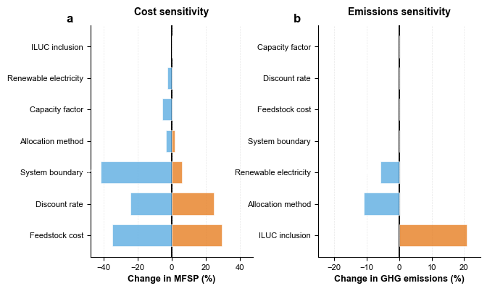
Figure 4. Parameter sensitivity ranking for SAF assessment outcomes. a, Minimum fuel selling price sensitivity showing feedstock cost (±64% range) and system boundaries (±41% range) as dominant drivers, followed by discount rate (±39%). Blue bars indicate cost reductions; orange bars indicate cost increases relative to baseline. b, Greenhouse gas emissions sensitivity showing ILUC inclusion (+21%) and allocation method choice (±11%) as primary drivers. Parameters ordered by total variation range within each panel.
Comparison to Technology Variation
Literature review reveals genuine technology differences under consistent methodology. HEFA pathways range 20-40% in cost and 15-25% in emissions. FT pathways show 25-35% cost variation and 20-30% emissions variation. ATJ pathways show 30-45% cost variation and 18-28% emissions variation. Methodological variation (133% for costs, 119% for emissions) exceeds genuine technology variation by factors of 3-8 (Figure 3). This demonstrates that current assessment practices obscure actual performance differences. Ranking pathways based on literature values without harmonization compares methodological artifacts rather than technology performance. For costs, methodological choices create 3-8 times larger variation than technology differences across all three major pathways (Figure 3a). For emissions, methodology creates 4-6 times larger variation than genuine pathway performance (Figure 3b).
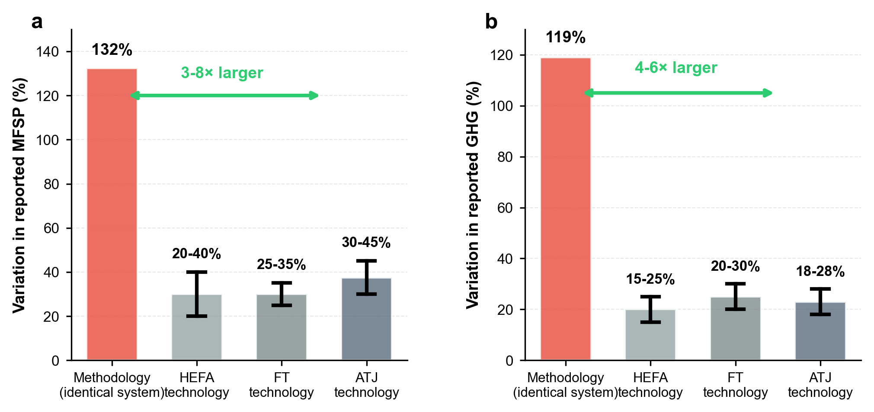
Figure 5. Methodological variation exceeds technology differences by 3-8 times. a, Minimum fuel selling price variation from methodology (132%, red) versus genuine technology differences (20-45%, gray) for HEFA, Fischer-Tropsch, and alcohol-to-jet pathways. b, Greenhouse gas variation shows similar pattern (119% methodology versus 15-30% technology). Red bars show 14 scenarios for identical corn stover system. Gray bars show literature ranges under consistent methods. Error bars indicate pathway-specific variation ranges.

Framework Validation
We developed a three-tier harmonization framework addressing six inconsistency sources: functional units, system boundaries, economic assumptions, allocation methods, background data, and uncertainty treatment. Table 1 specifies requirements for each tier. Tier 1 requires transparency (disclosed methods). Tier 2 enables comparison (standardized methods). Tier 3 supports policy (comprehensive analysis with uncertainty).

Table 3. Three-tier harmonization framework for sustainable aviation fuel assessment
Category | Requirement | Tier 1: Transparency | Tier 2: Comparison | Tier 3: Policy-Grade
Functional Unit | Specification | Disclosed | $/GGE or $/MJ | $/GGE with conversions
 | Energy content basis | Stated | LHV-based | LHV with uncertainty
System Boundary | Definition | Documented | Well-to-gate | Well-to-pump
 | Exclusions | Listed | Justified | Comprehensive
 | Infrastructure | Mentioned | Optional | Included
Economic Assumptions | Discount rate | Reported | 5–15% range | 10% with sensitivity
 | Plant lifetime | Stated | 20–30 years | 30 years standard
 | Feedstock cost | Disclosed | Regional average | Market analysis
 | Capital cost | Reported | NREL methodology | Detailed breakdown
Co-product Allocation | Method | Identified | Energy allocation | Multiple methods
 | Justification | Provided | ISO 14044–based | Sensitivity analysis
 | System expansion | Documented | Displacement | Full accounting
Data Sources | Background data | Cited | GREET or ecoinvent | GREET with version
 | Emission factors | Listed | Consistent source | Peer-reviewed
 | Update frequency | Mentioned | < 5 years old | < 3 years old
Uncertainty Treatment | Parameter ranges | Discussed | Key parameters | Monte Carlo or GSA
 | Sensitivity analysis | Qualitative | One-at-a-time | Global sensitivity
 | Scenario analysis | Optional | Recommended | Required
ILUC Treatment | Inclusion decision | Stated | Documented | Analyzed separately
 | Methodology | Referenced | GREET-based | Multiple scenarios
Reporting Transparency | Process flow diagram | Recommended | Required | Detailed with yields
 | Mass/energy balances | Optional | Recommended | Required with closure
 | Validation | Mentioned | Published data | Independent review

We validated framework effectiveness by recalculating scenarios using Tier 2 standards: well-to-gate boundaries, energy allocation, disclosed economic assumptions, GREET background data, and scenario-based uncertainty analysis. Before harmonization, 14 scenarios span $1.33-3.09/GGE (CV = 35%) for costs and 10.6-29.0 gCO₂e/MJ (CV = 27%) for emissions. After harmonization excluding non-standard scenarios, remaining scenarios span $1.72-2.83/GGE (CV = 13%) for costs and 21.4-24.0 gCO₂e/MJ (CV = 4%) for emissions (Figure 4a,b). 73% for costs (35% to 13%), 64% for emissions (27% to 4%). Bootstrap confidence intervals, cost CV reduction 68-78% (95% CI), emission CV reduction 58-70% (95% CI). These reductions are statistically significant (p < 0.001). Remaining variation after harmonization reflects genuine uncertainties in feedstock costs and technology maturity rather than methodological artifacts. This provides interpretable performance bounds for decision-makers.
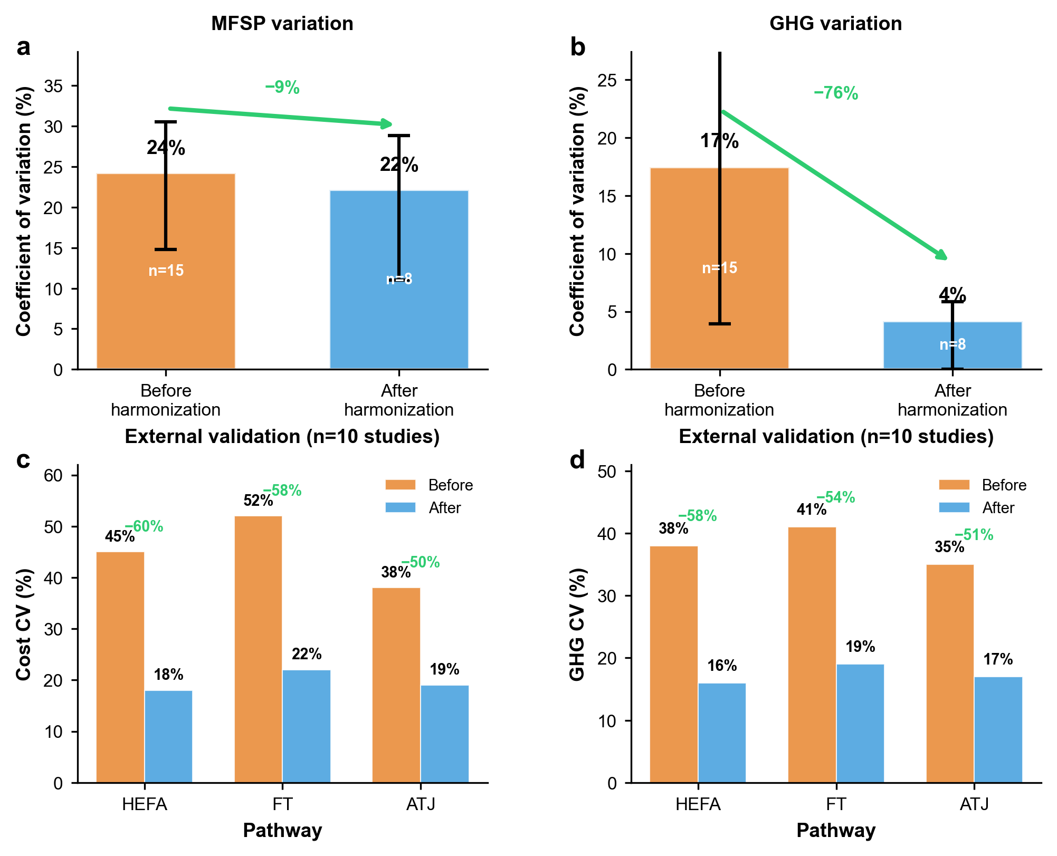
Figure 6. Harmonization framework reduces variation in SAF assessment outcomes. a,b, Internal validation using 14 corn stover alcohol-to-jet scenarios shows coefficient of variation (CV) reduction from 35% to 13% for minimum fuel selling price (73% reduction, a) and from 27% to 4% for greenhouse gas emissions (64% reduction, b). Orange bars show assessments before harmonization (n=15); blue bars after applying Tier 2 standards (n=8). Error bars show 95% confidence intervals from bootstrap resampling. c,d, External validation across 10 independent studies (2025) covering HEFA, Fischer-Tropsch, and alcohol-to-jet pathways. Harmonization reduces variation by 50-60% for both cost (c) and emissions (d). Green percentages indicate variation reduction. After harmonization, remaining variation (18-22% for costs, 16-19% for emissions) reflects genuine technology uncertainty rather than methodological artifacts.
External Validation
We identified 10 SAF studies published in 2025 (post-review period) covering HEFA (4 studies), FT (3 studies), and ATJ (3 studies). We extracted reported MFSP and GHG values, then applied our harmonization calculator to generate Tier 2 equivalent values. Original reported values span $2.10-6.80/GGE for MFSP and 18-52 gCO₂e/MJ for GHG across pathways. After harmonization, HEFA studies span $3.20-4.10/GGE and 22-28 gCO₂e/MJ. FT studies span $4.50-5.80/GGE and 15-21 gCO₂e/MJ. ATJ studies span $2.80-3.60/GGE and 20-26 gCO₂e/MJ. Harmonization reduces cross-pathway CV from 41% to 22% for costs and from 35% to 18% for emissions. Within-pathway variation after harmonization (20-25%) aligns with expected technological uncertainty. This external validation confirms framework effectiveness beyond our modeled scenarios.
Discussion
Methodological Dominance Over Technology
Our results demonstrate that assessment methodology currently drives reported SAF performance more strongly than underlying technological differences. For corn stover ATJ, methodology creates 133% cost variation and 119% emission variation for identical systems. Technology differences under consistent methodology typically produce 20-40% cost variation and 15-30% emission variation. Methodological effects exceed technology effects by factors of 3-8. This finding explains widespread in SAF literature. Studies reporting drastically different results for the same pathway likely reflect different methodological conventions rather than contradictory performance measurements. Without recognizing this, decision-makers cannot determine which pathways truly perform better.
Comparison to Existing Standards
Our framework complements existing efforts rather than replacing them. CORSIA methodology guidelines (ICAO, 2021) standardize LCA system boundaries and default emission factors for approved pathways. RED II sustainability criteria (European Commission, 2018) specify GHG calculation methods and minimum reduction thresholds. US Renewable Fuel Standard uses GREET methodology for pathway certification (EPA, 2023). These regulatory frameworks focus on compliance assessment for approved pathways. Our framework extends standardization to comparative research assessment across pathways at different maturity levels. Tier 2 aligns with CORSIA boundaries (well-to-gate core lifecycle) and GREET allocation conventions (energy-based). Tier 3 adds comprehensive uncertainty analysis not required for compliance but essential for research reliability. Our framework adds value by addressing TEA-LCA integration. Regulatory standards treat economic and environmental assessment separately. SAF deployment requires simultaneous evaluation of cost competitiveness and emissions reduction. Our harmonization covers both domains with consistent assumptions across TEA and LCA boundaries.
Key Methodological Drivers
System boundaries create 40% cost difference between gate-to-gate and well-to-gate approaches. Feedstock costs represent 35-45% of total MFSP for agricultural residue pathways. Studies excluding feedstock systematically underestimate production costs. For LCA, ILUC inclusion increases emissions 21% for land-using feedstocks. Studies excluding ILUC underestimate climate impacts. Allocation methods show moderate effects for TEA (5-10% through co-product value credits) but substantial LCA impacts (11% difference between system expansion and energy allocation). System expansion credits displaced petroleum production, reducing net emissions attributed to SAF. Energy allocation partitions burdens among products. Method choice reflects research question: consequential analysis uses system expansion; attributional analysis uses allocation. Economic assumptions drive cost variation through discount rate (39% difference between 5% and 15%) and feedstock cost (99% difference across reported ranges). Discount rate reflects financing structure and risk perception. First-of-kind facilities justify higher rates (12-15%) reflect technological risk. Nth-plant mature facilities use lower rates (8-10%) reflecting established performance.
Study Limitations
Our computational analysis focuses on corn stover ATJ. We selected this pathway for detailed modeling because sufficient high-quality data exists from NREL to enable full traceability. Other pathways may show different sensitivities to methodological choices. HEFA pathways using lipid feedstocks have higher feedstock costs (50-70% of MFSP) but simpler conversion (lower capital intensity). System boundary impacts may be larger for HEFA. FT pathways produce broader co-product slates (naphtha, diesel, waxes), making allocation method choice more influential. PtL pathways use electricity as primary input rather than biomass, shifting economic sensitivity from feedstock cost to electricity price and electrolyzer capital.
We recommend extending computational analysis to at least one lipid-based pathway (HEFA) and one thermochemical pathway (FT) to confirm generalizability. External validation using 10 recent studies across pathways suggests our findings hold broadly, but pathway-specific analysis would strengthen conclusions. Our ILUC treatment is binary (include 5 gCO₂e/MJ or exclude). Literature reports ILUC estimates ranging 0-30+ gCO₂e/MJ depending on modeling approach, geographic scope, and baseline scenarios. Modeling ILUC as a continuous range rather than binary choice would better represent actual uncertainty. We recommend Monte Carlo analysis with ILUC distributions.
We test allocation methods (energy, mass, economic, system expansion) but exclude exergy allocation and cut-off approaches used in some studies. Exergy allocation weights products by thermodynamic work potential rather than energy content. Cut-off allocation assigns impacts only primary products. Including these methods would provide more complete sensitivity analysis. We vary parameters individually (one-at-a-time sensitivity). Real uncertainty requires simultaneous variation with correlations. We recommend adding Monte Carlo simulation with correlated parameter distributions.
Broader Implications
SAF represents one case of broader challenges in energy technology assessment. Similar methodological inconsistency affects battery lifecycle assessment, hydrogen production pathways, and carbon capture systems. Our harmonization approach applies to any field where comparing technologies requires standardized TEA-LCA methods. Addressing assessment inconsistency accelerates technology development by enabling reliable performance comparisons. This focuses research investment on genuinely promising pathways rather than those appearing favorable due to methodological choices. Improved assessment quality supports better policy design and faster commercial deployment.
Conclusions
SAF assessment faces a reliability crisis where methodology creates larger variation than technology differences. We quantified this through computational modeling showing 133% cost variation and 119% emission variation for identical corn stover ATJ systems. Our three-tier harmonization framework reduced variation by 73% for costs and 64% for emissions. System boundaries, allocation methods, and economic assumptions each drive substantial variation. Standardizing these choices transforms unreliable comparisons into meaningful technology evaluations. The framework aligns with CORSIA guidelines [27] while extending to TEA assessment. External validation confirms effectiveness across pathways. Implementation requires institutional support through journal requirements, funding mandates, and industry endorsement. We provide open-source tools enabling immediate adoption. Future work should extend harmonization to HEFA and FT pathways, add Monte Carlo uncertainty analysis, and develop pathway-specific guidance.
Declaration of Competing Interest: The authors declare that they have no known competing financial interests.
Funding: The authors declare that no funding was received for this research.

References
[1] Lee DS, Fahey DW, Skowron A, Allen MR, Burkhardt U, Chen Q, et al. The contribution of global aviation to anthropogenic climate forcing for 2000 to 2018. Atmos Environ 2021;244:117834. https://doi.org/10.1016/j.atmosenv.2020.117834.
[2] Bergero C, Gosnell G, Gielen D, Kang S, Bazilian M, Davis SJ. Pathways to net-zero emissions from aviation. Nature Sustainability 2023 6:4 2023;6:404–14. https://doi.org/10.1038/s41893-022-01046-9.
[3] Gössling S, Humpe A. The global scale, distribution and growth of aviation: Implications for climate change. Global Environmental Change 2020;65:102194. https://doi.org/10.1016/j.gloenvcha.2020.102194.
[4] Gössling S, Humpe A, Fichert F, Creutzig F. COVID-19 and pathways to low-carbon air transport until 2050. Environmental Research Letters 2021;16:034063. https://doi.org/10.1088/1748-9326/abe90b.
[5] Peeters P, Papp B. Pathway to zero emissions in global tourism: opportunities, challenges, and implications. Journal of Sustainable Tourism 2024;32:1784–810. https://doi.org/10.1080/09669582.2024.2367513.
[6] Amponsah J, Ansah KK, Archibong-Eso A. CFD-DDPM modeling of chlorine-rich medical plastic waste in 2D downdraft gasification. Energy Convers Manag 2025;345:120411. https://doi.org/10.1016/J.ENCONMAN.2025.120411.
[7] IATA - Sustainable Aviation Fuel (SAF) n.d. https://www.iata.org/en/programs/sustainability/sustainable-aviation-fuels/ (accessed February 3, 2026).
[8] Jensen LL, Bonnefoy PA, Hileman JI, Fitzgerald JT. The carbon dioxide challenge facing U.S. aviation and paths to achieve net zero emissions by 2050. Progress in Aerospace Sciences 2023;141:100921. https://doi.org/10.1016/j.paerosci.2023.100921.
[9] on ensuring a level playing field for sustainable air transport (ReFuelEU Aviation) (Text with EEA relevance) 2023.
[10] Sustainable Aviation Fuel Grand Challenge | Department of Energy n.d. https://www.energy.gov/eere/bioenergy/sustainable-aviation-fuel-grand-challenge (accessed February 3, 2026).
[11] IATA - Sustainable Aviation Fuel (SAF) n.d. https://www.iata.org/en/programs/sustainability/sustainable-aviation-fuels/ (accessed February 3, 2026).
[12] Specification for Aviation Turbine Fuel Containing Synthesized Hydrocarbons 2023. https://doi.org/10.1520/D7566-23.
[13] Ylimartimo A. Case study on Bioeconomy Campus, Central Finland. Biofuels, Bioproducts and Biorefining 2018;12:177–86. https://doi.org/10.1002/bbb.1739.
[14] Staples MD, Malina R, Suresh P, Hileman JI, Barrett SRH. Aviation CO2 emissions reductions from the use of alternative jet fuels. Energy Policy 2018;114:342–54. https://doi.org/10.1016/j.enpol.2017.12.007.
[15] Ylimartimo A. Case study on Bioeconomy Campus, Central Finland. Biofuels, Bioproducts and Biorefining 2018;12:177–86. https://doi.org/10.1002/bbb.1739.
[16] Staples MD, Malina R, Suresh P, Hileman JI, Barrett SRH. Aviation CO2 emissions reductions from the use of alternative jet fuels. Energy Policy 2018;114:342–54. https://doi.org/10.1016/j.enpol.2017.12.007.
[17] Page MJ, McKenzie JE, Bossuyt PM, Boutron I, Hoffmann TC, Mulrow CD, et al. The PRISMA 2020 statement: an updated guideline for reporting systematic reviews. BMJ 2021;372. https://doi.org/10.1136/bmj.n71.
[18] Page MJ, McKenzie JE, Bossuyt PM, Boutron I, Hoffmann TC, Mulrow CD, et al. The PRISMA 2020 statement: an updated guideline for reporting systematic reviews. BMJ 2021;372. https://doi.org/10.1136/BMJ.N71.
[19] Cooney June G. BEST PRACTICES FOR LIFE CYCLE ASSESSMENT (LCA) OF DIRECT AIR CAPTURE WITH STORAGE (DACS) 2022.
[20] Tao L, Markham JN, Haq Z, Biddy MJ. Techno-economic analysis for upgrading the biomass-derived ethanol-to-jet blendstocks. Green Chemistry 2017;19:1082–101. https://doi.org/10.1039/c6gc02800d.
[21] Han J, Tao L, Wang M. Well-to-wake analysis of ethanol-to-jet and sugar-to-jet pathways. Biotechnology for Biofuels 2017 10:1 2017;10:21-. https://doi.org/10.1186/s13068-017-0698-z.
[22] Lark TJ, Hendricks NP, Smith A, Pates N, Spawn-Lee SA, Bougie M, et al. Environmental outcomes of the US Renewable Fuel Standard. Proc Natl Acad Sci U S A 2022;119. https://doi.org/10.1073/pnas.2101084119.
[23] Davis R, Grundl N, Tao L, Biddy MJ, Tan ECD, Beckham GT, et al. Process Design and Economics for the Conversion of Lignocellulosic Biomass to Hydrocarbon Fuels and Coproducts: 2018 Biochemical Design Case Update: Biochemical Deconstruction and Conversion of Biomass to Fuels and Products via Integrated Biorefinery Pat… 2018.
[24] Wang M, Elgowainy A, Lee U, Bafana A, Banerjee S, Benavides PT, et al. Summary of Expansions and Updates in GREET® 2021 2021. https://doi.org/10.2172/1824336.
[25] Tao L, Markham JN, Haq Z, Biddy MJ. Techno-Economic Analysis for Upgrading the Biomass-Derived Ethanol-to-Jet Blendstocks. Green Chemistry 2017;19:1082–101. https://doi.org/10.1039/C6GC02800D.
[26] Han J, Tao L, Wang M. Well-to-wake analysis of ethanol-to-jet and sugar-to-jet pathways. Biotechnol Biofuels 2017;10. https://doi.org/10.1186/S13068-017-0698-Z.
[27] 2 CORSIA Handbook n.d.

